IBM PROJECT REPORT

Smart restaurant bot

BY

A.JAFFLET TRINISHIA

**SYNOPSIS**

**1.ABSTRACT**

**2.INTRODUCTION**

**3.AIM OF THE PROJECT**

**4.LITERATURE SURVEY**

**5.PROBLEM STATEMENT**

**6.EXISTING SYSTEM**

* **Disadvantages­­**

**7.PROPOSED SYSTEM**

* **Advantages**

**8. SYSTEM ARCHITECTURE**

* **SYSTEM REQUIREMENTS**

**9..METHODOLOGY**

**10. WORKING**

**11.SCREENSHORT**

**12.** **APPLICATION LINK**

**13.CONCLUSION**

**1.ABSTRACT**

A bot is software which will respond back to user inputs, relying upon the input keywords. ... All such scenarios are only possible when there's some AI in an exceedingly software system which will prompt relevant business units when an incident occurs. No human intervention required. Chatbot, shortly know for chatterbot, is an Artificial Intelligence (AI) feature that can be embedded and used through any major messaging applications.  There are a number of synonyms for **chatbot**, including "talkbot," "**bot**," "IM **bot**," "interactive agent" or "**artificial** conversation entity."

**2.INTRODUCTION:**

Artificial intelligence has made chatbots more lifelike than ever before, and they are becoming pervasive. Talking bots are taking pizza orders, reserving hotel rooms, and scheduling appointments. In short, these robots are all around us.

**3.AIM OF THE PROJECT**

To maximize the ability of artificial intelligence (AI) chatbots to improve service, save money, and increase engagement, businesses and organizations need to understand how these programs work and what they can do. In this guide, you’ll get a crash course on talking bots, including the technology behind them, how they have transformed marketing and customer service, and how you can start putting them to work.

**4.LITERATURE SURVEY :**

**TITLE:**

A Study of Today’s A.I. through Chatbots and Rediscovery of Machine Intelligence

**AUTHOR:**

Anirudh Khanna1 , Bishwajeet Pandey1 , Kushagra Vashishta1 , Kartik Kalia1 , Bhale Pradeepkumar and Teerath Das

**DEFINITION:**

The paper shows how current approach towards A.I. is not adequate and offers a new theory that discusses machine intelligence, throwing light to the future of intelligent systems.And also it explains that the creation and analysis of intelligent agents (software and machines) is called Artificial Intelligence, or AI. It can be implemented in nearly each and every sphere of work. Intelligent machines can do many tasks – from labor work to sophisticated operations

**TITLE:**

A NEW BUSINESS MARKETING TOOL: CHATBOT YENİ BİR PAZARLAMA ARACI: CHATBOT

**AUTHOR:**

Ayşe Barış

**DEFINITION:**

The main objective is to find out how chatbots can contribute to business marketing strategies and how businesses should develop it so they can be used for communication with customers. The chatbot named Beauty gifter, created in 2017 by L'Oréal Paris, is selected as a case study. The results of the study shows that chatbots can be a great tool for customer communication but businesses should be paying a lot of attention to customer’s mindset and develop chatbots by using AI more efficiently.

**TITLE:**

Factors Influencing Adoption Intention of AI Powered Chatbot for Public Transport Services within a Smart City

**AUTHOR:**

Sachin Kuberkar and Tarun Kumar Singhal

**DESCRIPTION:**

The Chatbot solution in this study has social implications in terms of attracting more citizens to use public transport instead of their private vehicles thereby reducing congestion, travel delays, and climate pollution. They also provides vital insights to public transport officials and policymakers while designing or upgrading public transport information systems in a developing country like India. This study makes a novel contribution to literature as it empirically validates the intention to use AI powered Chatbot for public transport in the context of a large developing country like India.

**5.PROBLEM STATEMENT:**

Artificial intelligence chatbot is a technology that makes interactions between man and machines using natural language possible. From literature, we found out that in general, chatbot are functions like a typical search engine. Although chatbot just produced only one output instead of multiple outputs/results, the basic process flow is the same where each time an input is entered, the new search will be done. Nothing related to previous output. This research is focused on enabling chatbot to become a search engine that can process the next search with the relation to the previous search output. In chatbot context, this functionality will enhance the capability of chatbot’s input processing . Chatbots can greatly relieve the pressure and inquiry volume for call centers by handling basic questions and issues on their own or seamlessly routing customers to live agents who can address the more pressing, complex customer service issues that still require a human touch.

**6.EXISTING METHOD:**

The orders has to be manually taken by the restaurant staffs in that’s the case the customer has to be in the table with their orders ready

**6.1Disadvantages:**

* Health and Safety
* Personnel Management

## Profitability

## Time Commitment

## Tips for the staffs can be avoided

## 7.PROPOSED SYSTEM:

## Develop an end to end mobile application capable of managing/placing orders, displaying recommendations, showing the menu, prompting the best deals or collecting the customer feedback using the IBM Watson Assistant. The customer and the order details are stored in the Cloudant DB. Alert is sent when the order is confirmed using the Cloud Messaging. Speech to Text and Text to Speech Services must be used to take the speech input and give out the speech output.

## 7.1Advantage:

## Using chatbot we can manage users reservations and orders

## We can give food recommendations and display the menu to the users

## We can Promote best deals and offers on that day

## We will store the customer’s details and orders in the database

## Chat will send a notification to customers if the order is confirmed

## The chatbot is also useful in Follow up on customer feedback

## 8.SYSTEM REQUIREMENTS :

## IBM Watson

## Text To Speech

## Speech To Text

## Android App

## IBM Watson Assistant

## IBM Cloudant DB

**8.1 SYSTEM ARCHITECTURE**

## 

## 9.METHODOLOGY:

## 9.1.SPEECH TO TEXT:

## The IBM Watson™ Speech to Text service provides APIs that use IBM's speech-recognition capabilities to produce transcripts of spoken audio. The service can transcribe speech from various languages and audio formats. In addition to basic transcription, the service can produce detailed information about many different aspects of the audio. For most languages, the service supports two sampling rates, broadband and narrowband. It returns all JSON response content in the UTF-8 character set.

## 9.2.TEXT TO SPEECH:

## Watson Text-to-Speech, you can generate human-like audio from written text.  Improve the customer experience and engagement by interacting with users in multiple languages and tones. Increase content accessibility for users with different abilities, provide audio options to avoid distracted driving, or automate customer service interactions to increase efficiencies.

## 9.3. Watson Assistant

## IBM Watson Assistant is a white label cloud service that allows enterprise-level software developers to embed an artificial intelligence (AI) virtual assistant (VA) in the software they are developing and brand the assistant as their own.

## 10.WORKING:

### IBM Academic Initiative Account

### Create A Cloud Function

### Create CloudantDB

### Create STT(Speech To Text)

### Create TTS(Text To Speech)

### Create Fast2SMS

* Build chat bot using Watson assistant

### Integrating External API To Chatbot To Send SMS Using Fast2SMS Service.

### Create Node-Red Service

### Integrate Node Red To Watson Assistant

### Integrate CloudantDB

### Integrate TTS(Text To Speech)

### Integrate STT(Speech To Text)

**11.SCREENSHORTS OF OUTPUT:**

**Watsoon assistant**

<https://web-chat.global.assistant.watson.cloud.ibm.com/preview.html?region=eu-gb&integrationID=6ecb6658-025b-416c-94bc-b7a061af74d3&serviceInstanceID=d3ffa5df-72a0-4ac1-8d85-f9698f037a6b>

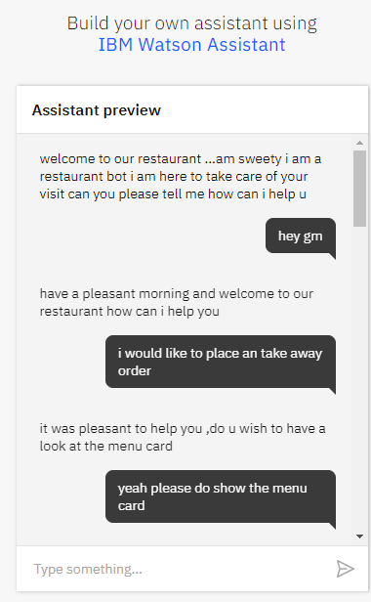

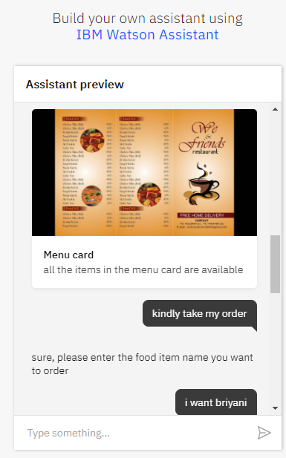 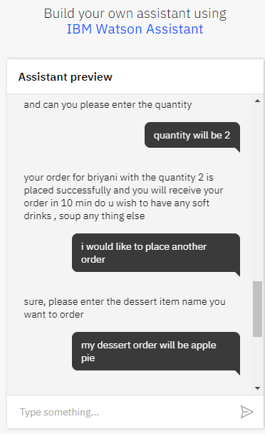 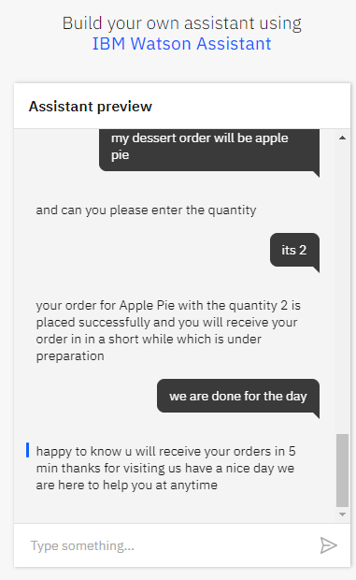

## RED-NODE

## OVER-VIEW:

## 

## SCREENSHORT:

## 

## 

## 

## 

## 

## 

## 

## 12.APPLICATION LINK:

## <https://node-red-ixaco-2020-12-04.eu-gb.mybluemix.net/ui/#!/0?socketid=mS4hfYe2DyKsmIIxAAAp>

## 13.CONCLUSION:

## From my perspective, chatbots or smart assistants with artificial intelligence are dramatically changing businesses. ... Chatbots can reach out to a large audience on messaging apps and be more effective than humans. They may develop into a capable information-gathering tool in the near future